Personnel responsible:
All Production

Safety equipment:
- All safety glasses and appropriate safety apparel is to be worn at all times.
- Bump caps or safety helmets worn in designated areas
- When entering different areas of the plant, be aware of work being done around you and any safety precautions that may be needed in that area.

Summary:
.
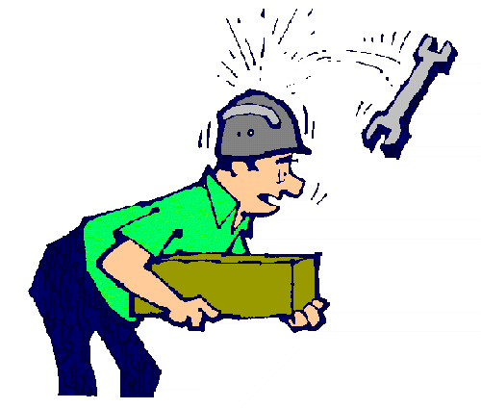
When work is being done overhead it is both the employees doing the work as well as the employees working below responsibility to make sure that the area is safe and secure at all times. This procedure is to inform employees of the proper actions to take before working over or under maintenance being performed.

Procedure:
- Creating and “Overhead Work Area”
  - An “Overhead Work Area” needs to be established when ever work will be performed on the 2nd or 3rd floors and personnel are present underneath.
  - Before starting any maintenance work:
    - Operations should be notified
    - Area should be roped off with a sign designating it as “Overhead Work Area”
    - Roped off area can only be dismantled when work is competed.

- Entering and working in a designated “Overhead Work Area”
  - Entering “Overhead Work Area”
    - Anyone entering this area must wear a bump-cap or Hard-hat
    - Notify overhead workers that you are entering or leaving this area.

TRAINING DOCUMENT

 | EMPLOYEE | TITLE | SIGNATURE | DATE
1
2
3
4
5
6
7
8
9
10
11
12
13
14
15
16
17
18
19
20

